**25.Email by deleting the part**

**Exercise**

* **Input an email from the user. You have to create a username from the email by deleting the part that comes after ‘@’. Display that username to the user.**

**Example :**

**email = “codexam@gmail.com” ; username = “codexam”**

**email = “helloWorld123@gmail.com”; username = “helloWorld123”**

**Approach:**

**So here we did like this**

**Java: Ctrl + “+” = zoom**

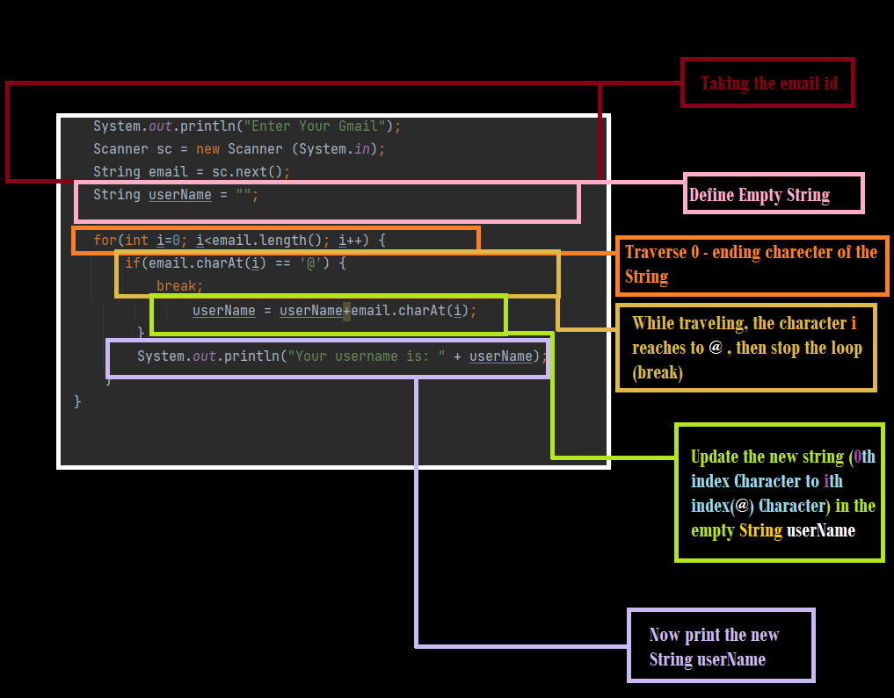

**##   Python: In python we're simply using slicing, we're printing from index 0 to (index of '@') -1**

**Solution 👇**

**Java :**

**import java.util.*;**

**public class CodeXam {**

**public static void main(String args[]) {**

**System.out.println("Enter Your Gmail");**

**Scanner sc = new Scanner (System.in);**

**String email = sc.next();**

**String userName = "";**

**/* //You can use this too**

**for(int i=0; i<email.length(); i++) {**

**if(email.charAt(i) == '@') {**

**break;**

**} else {**

**userName += email.charAt(i);**

**}**

**}**

**\*/**

**for(int i=0; i<email.length(); i++) {**

**if(email.charAt(i) == '@')**

**break;**

**userName = userName+email.charAt(i);**

**}**

**System.out.println("Your username is: " + userName);**

**}**

**}**

**output:**

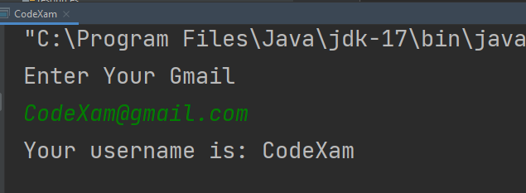

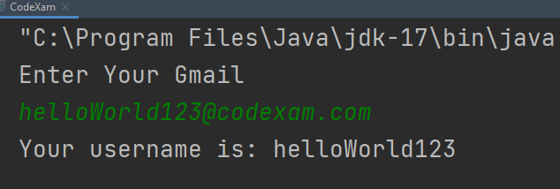

**Python :**

**user = input("Please enter your email id:\n")**

**x = user.index("@")**

**user_name = user[0:x]**

**print("Your username is:", user_name)**

**output:**

